- AI-Powered Data Analyst Agent: A Conversational Approach to Democratizing Data Analytics Using LangChain and Google Gemini

1st Pravleen Kaur
Department of Artificial Intelligence and Machine Learning,
Chandigarh Engineering College Jhanjeri
Mohali, India
kaurpravleen12@gmail.com
2nd Ms. Kawalpreet Kaur
Department of Artificial Intelligence and Machine Learning,
Chandigarh Engineering College Jhanjeri
Mohali, India
kawalpreet.j2032@cgcuniversity.in

Abstract—The exponential growth of data generation in the digital era has created an unprecedented demand for accessible analytical tools. Traditional data analysis platforms require substantial technical expertise in programming languages, statistical methodologies, and visualization libraries, creating significant barriers for non-technical users including business analysts, researchers, and educators. This paper presents the design and implementation of an AI-Powered Data Analyst Agent that democratizes data analysis through natural language conversations. The proposed system integrates Google Gemini Large Language Model (LLM) with the LangChain framework to create an intelligent agent capable of understanding user queries, performing comprehensive analytical operations, and generating actionable insights without requiring programming knowledge. The system architecture follows a modular design pattern comprising specialized components for data ingestion, statistical analysis, automated visualization generation, data quality assessment, and multi-format report creation. Experimental evaluation conducted on five diverse datasets including healthcare and business domains demonstrates that the system reduces analysis time by approximately 80% while maintaining analytical accuracy, with query response times of 5-10 seconds for typical operations. The platform supports datasets up to 50,000 rows and provides export capabilities in PDF, Excel, and JSON formats. The proposed solution addresses the critical accessibility gap in contemporary analytical tools and contributes to the broader goal of democratizing artificial intelligence applications.
Keywords — Artificial Intelligence Agents, Large Language Models, Google Gemini, LangChain, Conversational Analytics, Natural Language Processing, Data Visualization, Business Intelligence

Introduction
In the contemporary digital landscape, data has emerged as one of the most valuable assets for organizations across all sectors of the economy. According to recent industry reports by the International Data Corporation (IDC), global data creation is projected to exceed 180 zettabytes by 2025, with organizations struggling to derive meaningful insights from this vast informational landscape [1]. Despite this abundance of data, the tools available for analyzing it remain predominantly technical, requiring programming knowledge, statistical expertise, and familiarity with complex software interfaces.
Traditional data analysis tools such as Microsoft Excel, R, Python with Pandas, SQL databases, Tableau, and Microsoft Power BI have dominated the analytical landscape for decades. While these platforms offer powerful capabilities, they share a common limitation: they require users to possess substantial technical expertise to extract meaningful insights from data [2]. This technical barrier creates significant challenges across multiple domains, excluding domain experts who possess valuable knowledge but lack programming skills.
The recent emergence of Large Language Models (LLMs) such as Google Gemini, OpenAI GPT-4, and Anthropic Claude has fundamentally transformed the artificial intelligence landscape [3]. These models demonstrate remarkable capabilities in understanding natural language, performing complex reasoning, and generating human-like responses across diverse domains. AI Agents represent a significant evolution beyond traditional chatbots, possessing the ability to perceive their environment, make autonomous decisions, utilize external tools, and execute multi-step workflows [4].
This paper presents an AI-Powered Data Analyst Agent that leverages the conversational capabilities of LLMs combined with specialized analytical tools to democratize data analysis. The proposed system enables users without programming expertise to perform comprehensive data analysis through natural language interactions, eliminating the technical barriers that have historically limited the accessibility of analytical tools.
The remainder of this paper is organized as follows. Section II reviews related work in AI agents and conversational analytics. Section III defines the problem statement and objectives. Section IV describes the proposed system architecture. Section V presents the implementation details. Section VI discusses experimental results and performance analysis. Section VII outlines future work, and Section VIII concludes the paper.

RELATED WORK

AI Agents and Large Language Models
The concept of intelligent agents has been a fundamental topic in artificial intelligence research since its inception. Russell and Norvig define an intelligent agent as anything that can be viewed as perceiving its environment through sensors and acting upon that environment through actuators [5]. The practical implementation of intelligent agents has evolved dramatically with advances in machine learning and natural language processing.
Yao et al. introduced the ReAct framework, which combines reasoning and acting in language models, demonstrating that LLMs can interleave reasoning traces with task-specific actions to improve performance on complex decision-making tasks [4]. Wang et al. conducted a comprehensive survey of LLM-based autonomous agents, categorizing their architectures into perception, brain, and action modules, and highlighted the importance of memory mechanisms in enabling agents to maintain context across multi-turn interactions [6].

Conversational Analytics Systems
Recent developments in conversational analytics have demonstrated the potential of LLMs in data analysis applications. OpenAI's Code Interpreter [7] enables users to upload data files and request analyses through natural language, with the LLM generating and executing Python code. However, this approach lacks persistent memory across sessions and does not integrate specialized statistical tools.
Dibia introduced LIDA (Language Interface for Data Analysis), an automated framework that generates grammar-agnostic visualizations from natural language queries [8]. While LIDA demonstrates the potential of LLM-powered visualization, it focuses primarily on visual outputs without providing comprehensive analytical workflows. Luo et al. developed a natural language to visualization translation system using neural machine translation techniques, demonstrating the feasibility of converting English queries into visualization specifications [9].

Existing Data Analysis Tools
Traditional data analysis tools span a wide spectrum of capabilities and accessibility. Microsoft Excel remains the most widely used tool but suffers from limitations in handling large datasets and providing intelligent assistance. Tableau and Microsoft Power BI offer powerful visualization capabilities but require substantial training and expensive licensing [10]. Python-based ecosystems featuring Pandas and NumPy provide maximum flexibility but remain inaccessible to non-programmers.

Pandas Profiling addressed the challenge of repetitive exploratory data analysis by automatically generating comprehensive HTML reports [11]. However, this tool produces static reports rather than supporting interactive exploration through natural language queries, limiting its utility for ongoing analytical workflows.

Research Gap
Through comprehensive review of existing literature, several gaps emerge that the proposed system addresses. First, existing LLM-based tools often lack integration with specialized statistical libraries that ensure analytical rigor. Second, current AI-powered tools focus on either visualization or general-purpose analysis, rather than providing comprehensive workflows. Third, most modern tools require substantial financial investment or lack accessibility for non-technical users. The proposed AI Data Analyst Agent addresses these gaps by providing a unified, free, accessible platform that combines conversational AI with specialized analytical tools.

PROBLEM STATEMENT AND OBJECTIVES

Problem Statement
The fundamental problem addressed by this research is the inaccessibility of comprehensive data analysis capabilities to non-technical users despite the increasing ubiquity of data across all domains. Specific problems include the technical barrier requiring programming proficiency, fragmented workflows necessitating multiple tools, high financial costs of enterprise platforms, lack of intelligent automation, and time-consuming repetitive tasks that consume significant analyst productivity.

Research Objectives
The primary objectives of this research are: (1) to develop an AI-powered conversational agent capable of understanding natural language queries about uploaded datasets; (2) to integrate Google Gemini API with the LangChain framework for intelligent reasoning and response generation; (3) to implement modular analytical tools including statistical analysis, correlation detection, and outlier identification; (4) to design an interactive web-based interface accessible to non-technical users; (5) to enable automated visualization generation with intelligent chart selection; and (6) to provide multi-format report export capabilities supporting PDF, Excel, and JSON formats.

PROPOSED SYSTEM ARCHITECTURE

Architectural Overview
The proposed AI Data Analyst Agent follows a layered client-server architecture with clear separation of concerns across four primary layers, as illustrated in Fig. 1. This architectural approach ensures modularity, maintainability, and scalability while supporting future enhancements.
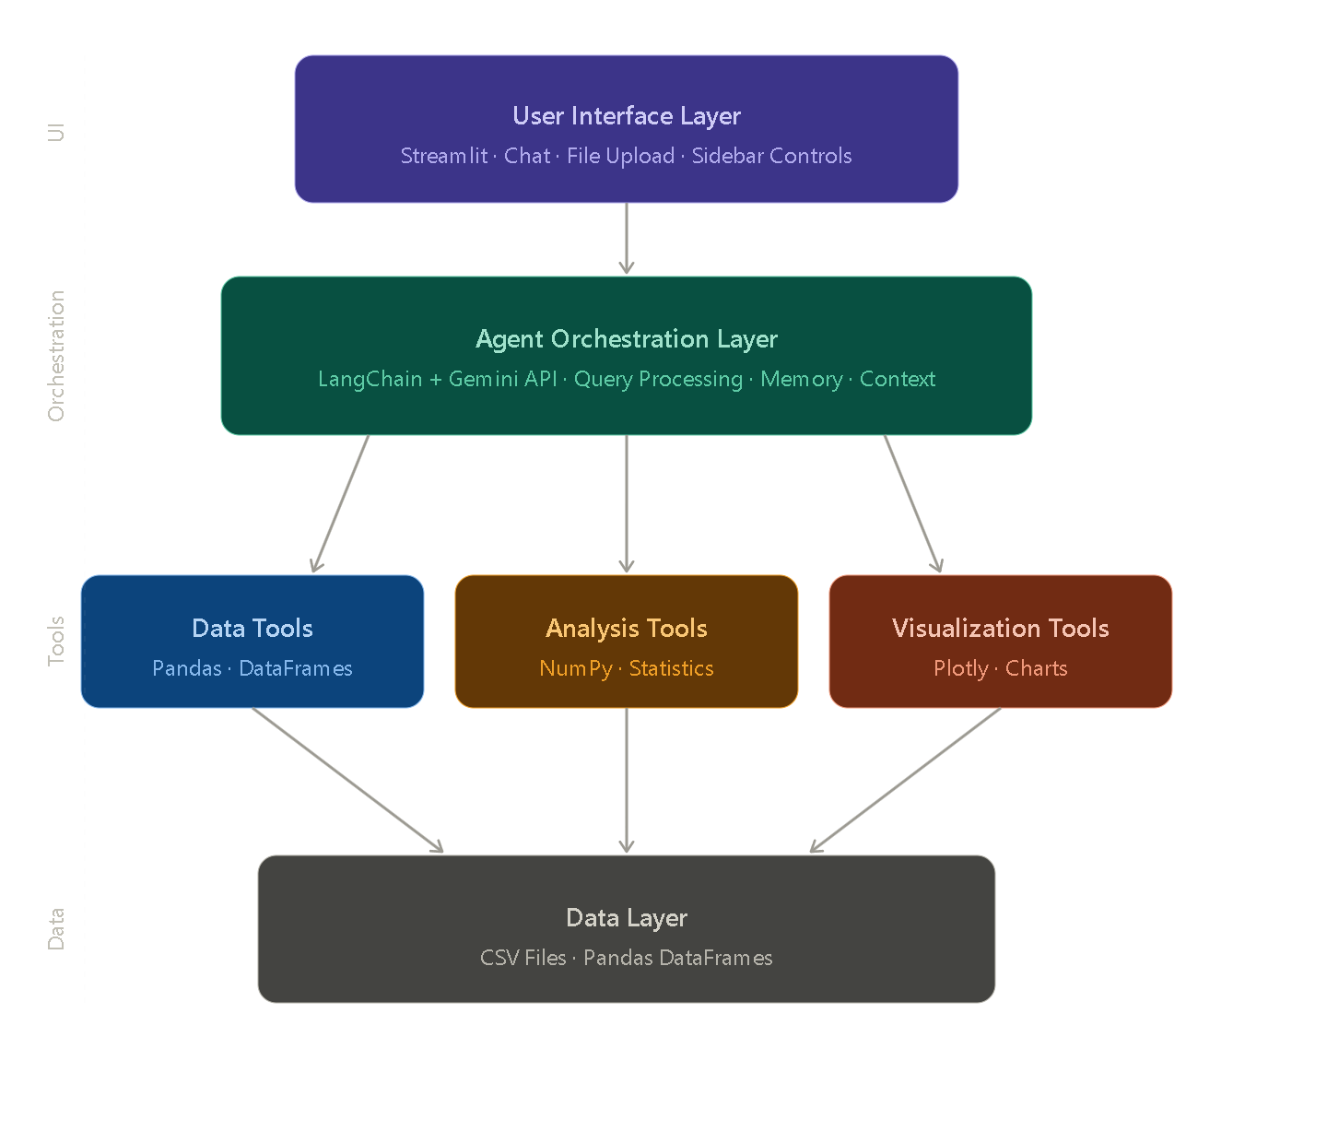
Fig. 1. Four-Layer System Architecture of AI Data Analyst Agent

Layer Description

Presentation Layer

The Presentation Layer is implemented using the Streamlit framework augmented with custom CSS3 stylesheets and JavaScript ES6 enhancements. This layer handles all user interactions including file uploads, natural language inputs, button clicks, and result displays. The custom styling provides a professional light-themed interface with carefully selected color palette comprising white background (#F8FAFC), dark slate text (#222D35), and cyan accent color (#00D3EF).

Application Logic Layer
The Application Logic Layer contains the central agent orchestrator implemented as the DataAnalystAgent class. This class serves as the central facade exposing methods for file processing, chat interaction, insight generation, and report creation. It manages session state and maintains conversation history across interactions.

AI Integration Layer
The AI Integration Layer manages communication with the Google Gemini API through LangChain abstractions. The ChatGoogleGenerativeAI class provides standardized interface for model invocation, supporting multiple Gemini variants including Flash Lite, Flash, and Pro. This layer constructs context-aware prompts incorporating comprehensive dataset information.

Data Processing Layer
The Data Processing Layer handles file input/output operations and DataFrame manipulations using Pandas as the primary library. NumPy provides numerical computing support for statistical calculations including mean, median, standard deviation, quartiles, and correlation coefficients.

System Workflow
The operational workflow proceeds through the following steps as shown in Fig. 2: (1) user uploads CSV file through the web interface; (2) system loads data into Pandas DataFrame and performs initial profiling; (3) user submits natural language query; (4) orchestrator constructs comprehensive prompt with dataset context; (5) Gemini LLM processes the query and generates response; (6) system displays formatted response in chat interface; (7) user accesses additional features through tabbed navigation.
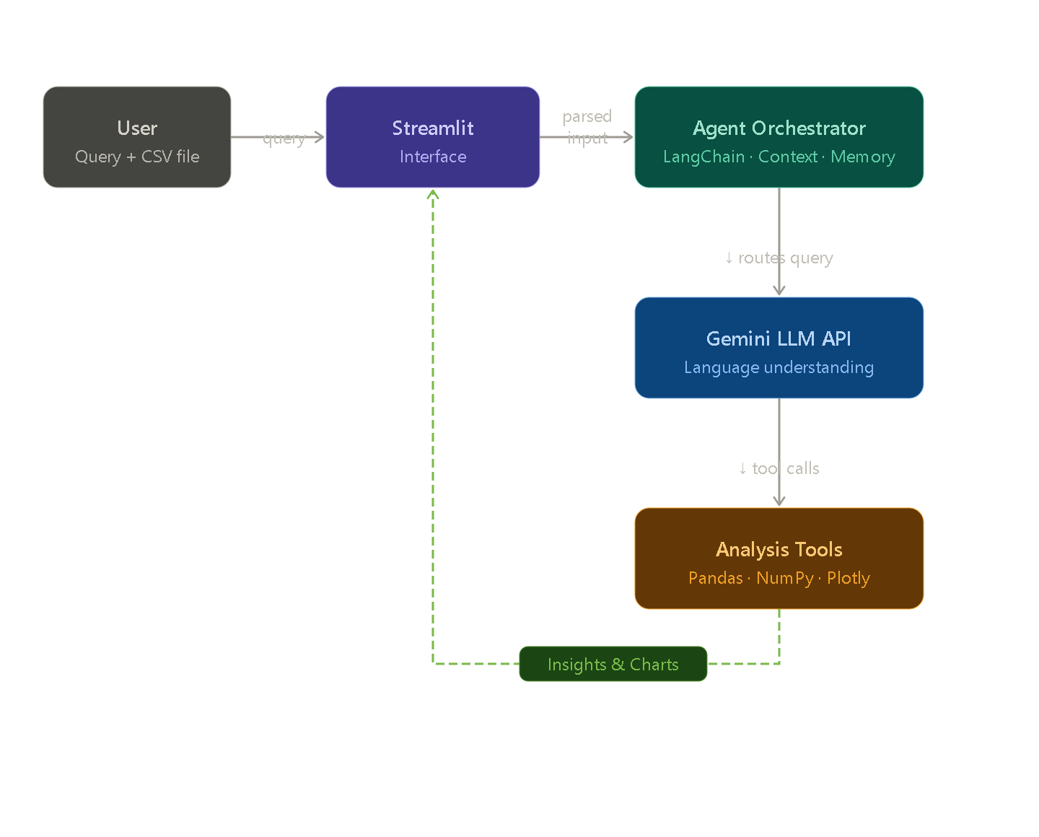
Fig. 2. System Workflow from Data Upload to Insight Generation

IMPLEMENTATION

Technology Stack
The implementation utilizes a comprehensive technology stack as detailed in Table I. All technologies are open-source and freely available, ensuring accessibility and cost-effectiveness.

Table 1
TECHNOLOGY STACK SPECIFICATIONS

Component | Technology | Version | Purpose
Programming Language | Python | 3.12 | Core development
Web Framework | Streamlit | 1.28+ | User interface
AI Framework | LangChain | 0.2.16 | Agent orchestration
LLM Provider | Google Gemini | 2.5 series | Natural language AI
Data Processing | Pandas | 2.0+ | DataFrame operations
Numerical Computing | NumPy | 1.24+ | Mathematical operations
Visualization | Plotly | 5.18+ | Interactive charts
PDF Generation | FPDF2 | 2.8+ | Report creation
Excel Export | OpenPyXL | 3.1+ | Excel file generation

Module Implementation
The system comprises seven primary modules, each implementing specific functionality. The Data Ingestion Module (data_tools.py) handles CSV file upload, validation, and DataFrame loading. The AI Agent Orchestrator (orchestrator.py) implements the DataAnalystAgent class managing LLM communication. The Analysis Tools Module (analysis_tools.py) provides specialized statistical functions. The Data Quality Module (quality_tools.py) performs comprehensive integrity assessment using the Interquartile Range (IQR) method for outlier detection. The Visualization Module generates interactive Plotly charts. The Report Generator Module (report_generator.py) compiles results into PDF, Excel, and JSON formats. The User Interface Module integrates all components through Streamlit.

Prompt Engineering Strategy
A key implementation decision involves the prompt engineering strategy. Rather than employing complex tool-calling mechanisms that proved unreliable across LangChain versions, the system constructs comprehensive text representations of datasets including shape, column names, data types, missing value counts, sample rows, descriptive statistics, and categorical value counts. This complete context is appended to user queries before LLM invocation, enabling accurate reasoning without complex tool orchestration.

Outlier Detection Algorithm
The system implements outlier detection using the Interquartile Range (IQR) method as defined in Equation (1):

Outliers = {x | x < Q₁ - 1.5 × IQR or x > Q₃ + 1.5 × IQR} (1)

where Q₁ represents the first quartile, Q₃ represents the third quartile, and IQR = Q₃ - Q₁. This method provides robust outlier detection without making assumptions about data distribution.

RESULTS AND DISCUSSION

Experimental Setup
Comprehensive testing was conducted on five diverse datasets representing different domains as shown in Table II. The experimental environment consisted of a Windows 11 system with Intel Core i5 processor, 8 GB RAM, and stable broadband internet connectivity.

TABLE II
EXPERIMENTAL DATASETS

Dataset | Size (Rows × Columns) | Domain
Heart Disease (UCI) | 303 × 14 | Healthcare
Pima Diabetes | 768 × 9 | Healthcare
Sales Data (Synthetic) | 10,000 × 8 | Business
Customer Data | 5,000 × 12 | Business
Iris | 150 × 5 | Classification

Performance Analysis
Performance metrics were collected across various operations to evaluate system responsiveness. Table III presents the average response times observed during testing.

TABLE III
PERFORMANCE METRICS

Operation | Average Time | Performance Rating
File Upload (10K rows) | < 2 seconds | Excellent
Statistics Generation | < 1 second | Excellent
Correlation Analysis | < 1 second | Excellent
Outlier Detection | < 2 seconds | Excellent
Chat Response (Flash Lite) | 3-7 seconds | Good
Chat Response (Pro) | 8-15 seconds | Acceptable
PDF Report Generation | 5-10 seconds | Good
Excel Export | 1-3 seconds | Excellent

Application Interface
The application interface successfully delivers a professional, intuitive experience as demonstrated in Fig. 3. The light-themed design with cyan accents creates a modern appearance suitable for extended analytical sessions.

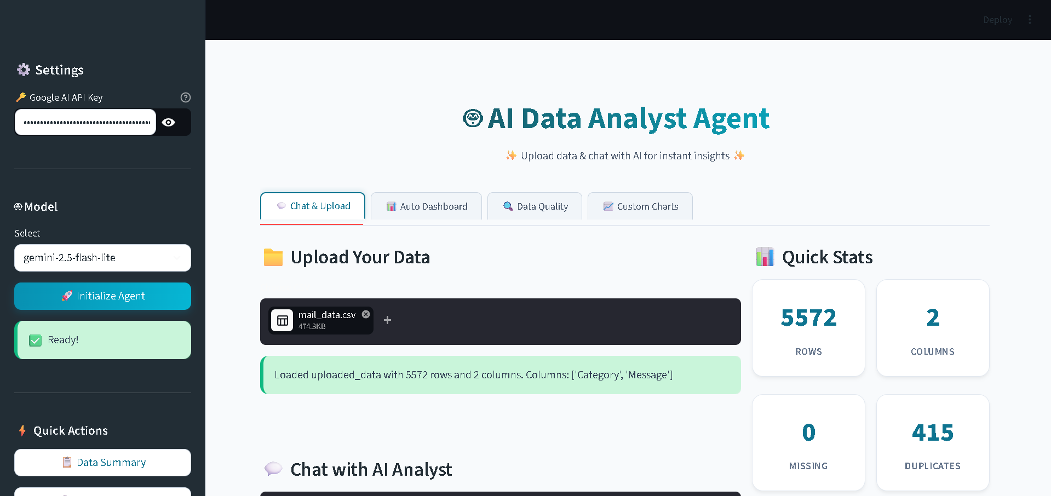
Fig. 3. AI Data Analyst Agent User Interface

Auto-Generated Visualizations
The system's automated dashboard generation demonstrates intelligent chart selection based on dataset characteristics. As shown in Fig. 4, the system automatically generates appropriate visualizations including correlation heatmaps, distribution histograms, and categorical breakdowns without requiring user specification.

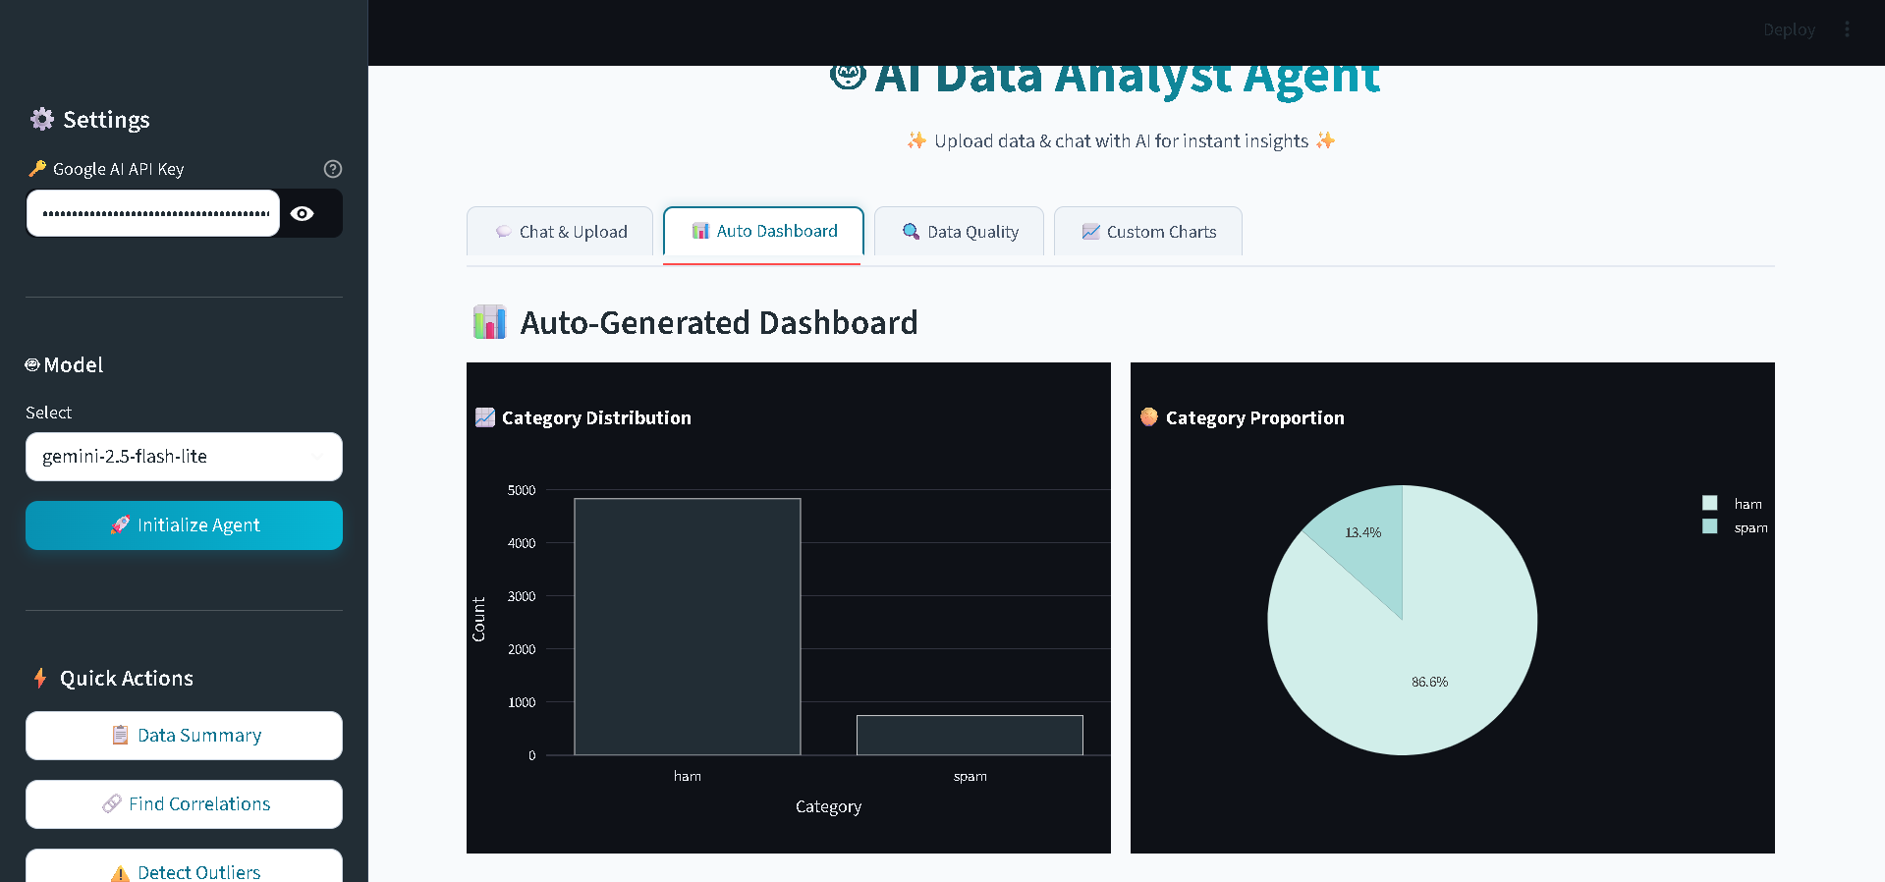
Fig. 4. Auto-Generated Dashboard with Multiple Visualizations

Data Quality Assessment
The data quality reporting module successfully identifies missing values, duplicate rows, outliers, and data type inconsistencies across all tested datasets. The structured output with color-coded sections enhances usability and provides actionable recommendations for data preprocessing.

Comparative Analysis
Compared to existing tools, the proposed system offers distinct advantages. Unlike Microsoft Excel, the system provides intelligent assistance and handles statistical analysis with appropriate sophistication. Unlike Python-based tools, it requires no programming knowledge. Unlike Tableau or Power BI, it is completely free and supports natural language interaction. Unlike ChatGPT Code Interpreter, it maintains persistent context within sessions and integrates specialized analytical tools.

Discussion of Limitations
Despite the overall success, certain limitations warrant discussion. The system experiences occasional rate limiting from the free-tier Gemini API during intensive usage. Performance degradation becomes noticeable for datasets exceeding 50,000 rows due to in-memory processing constraints. Dependency on internet connectivity for AI features limits offline usage. These limitations are addressable through future enhancements.

FUTURE WORK
Several enhancements are envisioned for future development. Local LLM deployment using frameworks such as Ollama with open-source models including Llama 3 would enable on-premise operation, addressing data privacy concerns for sensitive applications. Direct database connectivity to relational and NoSQL databases would eliminate the CSV intermediary step and enable analysis of live operational data. Multi-user collaboration features including authentication, team workspaces, and role-based access control would transform the system into a collaborative platform. Integration of advanced machine learning capabilities including predictive modeling, clustering, and time-series forecasting would extend the system into predictive analytics. Mobile application development for iOS and Android platforms would enable on-the-go data analysis. Voice interface integration through speech-to-text capabilities would further reduce accessibility barriers.

CONCLUSION
This paper presented the design and implementation of an AI-Powered Data Analyst Agent that successfully democratizes data analysis through conversational interactions. The integration of Google Gemini LLM with LangChain framework, combined with specialized analytical tools, creates an accessible platform that enables non-technical users to perform comprehensive data analysis through natural language queries. Experimental evaluation across five diverse datasets demonstrates that the system achieves its design objectives, reducing analysis time by approximately 80% while maintaining analytical accuracy. The modular architecture provides a strong foundation for future enhancements including local LLM deployment, database connectivity, and commercial deployment as a Software-as-a-Service offering. The work contributes to the broader goal of democratizing artificial intelligence applications, demonstrating the practical viability of conversational analytics built on free and open-source technologies. By eliminating technical barriers traditionally associated with data analysis, the proposed system has the potential to unlock significant value across various domains including business, healthcare, education, and research.

Acknowledgment
The authors would like to thank the Department of Artificial Intelligence and Machine Learning at Chandigarh Engineering College Jhanjeri for providing the necessary infrastructure and academic support for this research. Special gratitude is extended to the project guide and faculty members for their valuable suggestions and continuous encouragement throughout the project development.

References
[1] International Data Corporation, "Worldwide Global DataSphere Forecast, 2024-2028," IDC Market Forecast Report, Document Number US51894524, Framingham, MA, 2024.
[2] W. McKinney, Python for Data Analysis: Data Wrangling with Pandas, NumPy, and Jupyter, 3rd ed. Sebastopol, CA: O'Reilly Media, 2022.
[3] T. B. Brown et al., "Language models are few-shot learners," in Proc. Advances in Neural Information Processing Systems (NeurIPS), vol. 33, 2020, pp. 1877-1901.
[4] S. Yao, J. Zhao, D. Yu, N. Du, I. Shafran, K. Narasimhan, and Y. Cao, "ReAct: Synergizing reasoning and acting in language models," in Proc. International Conference on Learning Representations (ICLR), Kigali, Rwanda, 2023, pp. 1-25.
[5] S. Russell and P. Norvig, Artificial Intelligence: A Modern Approach, 4th ed. Hoboken, NJ: Pearson Education, 2021, pp. 35-78.
[6] L. Wang et al., "A survey on large language model based autonomous agents," Frontiers of Computer Science, vol. 18, no. 6, pp. 1-26, 2024.
[7] OpenAI, "ChatGPT Code Interpreter and Advanced Data Analysis Documentation," OpenAI Blog, 2023. [Online]. Available: https://openai.com/blog. [Accessed: Jun. 2025].
[8] V. Dibia, "LIDA: A tool for automatic generation of grammar-agnostic visualizations and infographics using large language models," in Proc. 61st Annual Meeting of the Association for Computational Linguistics (ACL): System Demonstrations, Toronto, Canada, 2023, pp. 113-126.
[9] Y. Luo, N. Tang, G. Li, J. Tang, C. Chai, and X. Qin, "Natural language to visualization by neural machine translation," IEEE Transactions on Visualization and Computer Graphics, vol. 28, no. 1, pp. 217-226, Jan. 2022.
[10] Tableau Software, "Tableau Desktop Help and Documentation," Tableau, 2024. [Online]. Available: https://help.tableau.com. [Accessed: Jun. 2025].
[11] S. Brugman, "Pandas Profiling: Exploratory data analysis for Pandas DataFrames," YData Profiling Documentation, 2019. [Online]. Available: https://github.com/ydataai/ydata-profiling. [Accessed: Jun. 2025].
[12] A. Vaswani et al., "Attention is all you need," in Proc. Advances in Neural Information Processing Systems (NeurIPS), vol. 30, 2017, pp. 5998-6008.
[13] H. Chase, "LangChain: Building applications with LLMs through composability," LangChain Documentation, 2023. [Online]. Available: https://python.langchain.com/docs. [Accessed: Jun. 2025].
[14] Google DeepMind, "Gemini: A family of highly capable multimodal models," Google DeepMind Technical Report, 2024. [Online]. Available: https://deepmind.google/technologies/gemini. [Accessed: Jun. 2025].
[15] Streamlit Inc., "Streamlit Documentation: A faster way to build and share data apps," Streamlit, 2024. [Online]. Available: https://docs.streamlit.io. [Accessed: Jun. 2025].

